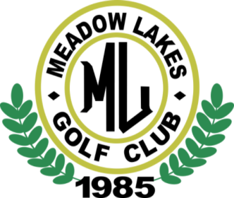

Operations Policy – Complimentary / Discounted Golf Rounds
Policy # 005-03-30 rev0 03/30/18

- The staff and owners of MLGC have taken extraordinary measures to offer a quality product to our community. A prerequisite to offer a quality product is revenue. Our general policy is that we DO NOT GIVE OUR PRODUCT AWAY.
- There are a very few exceptions to this rule as follows:
- MLGC will honor the golf pro complimentary round code. Only the General Manager, Head Golf Pro, Pro Shop Manager or Owner shall have the authority to approve a request from an external Golf Pro.
- Certain promotions may include complimentary rounds. Example – Atlanta / Rome Braves advertisement exchange. The Owner is the ONLY person who may approve this type of promotion.
- The Superintendant may approve complimentary rounds for business associates in the normal course of business.
- Employees – Employees of MLGC will not be charged any green or cart fees. Guest of employees may receive a 20% discount on green and cart fees only.
- Discounted rounds – The standard discount for promotions, member / employee guest, ect, is 20% (twenty percent). The Owner is the ONLY person who may approve any additional discount.
- All complimentary and discounted rounds played at MLGC are to be entered into the POS system.

